% For constant tourque 5Nm

clc

clear

TR = [0 5]; % time RANGE

X0 = [0;0;0;0];%initial conditions

[t,z] = ode45(@func1, TR, X0);%calling thr ide solver to solve by function

%storing given array as vectors

theta1 = z(:, 1);

AngVel1 = z(:, 2);

theta2 = z(:, 3);

AngVel2 = z(:, 4);

%plotting the angular displacements and velocities

acc1 = diff(AngVel1);

acc2= diff(AngVel2);

plot(t,theta1,t,AngVel1,t,[0;acc1],t,theta2,t,AngVel2,t,[0;acc2]);

xlabel('time')

legend('Angular Displacement 1','Angular Velocity 1','Angulara acceleration 1','Angular Displacement 2','Angular Velocity 2','Angulara acceleration 2')

ylabel('position & Velocity')

title("m-file")

%function containing the differentialequations

function dx = func1(~, x)

% Values of Coefficients

J1=1; J2=10; D1=0.9; D2=0.02; k=3;T=5;

% State Equations

dx(1) = x(2);

dx(3) = x(4);

dx(2) = (T-D1\*x(2)-k\*x(1)+k\*x(3))/J1;

dx(4) = (-k\*x(3)-D2\*x(4)+k\*x(1))/J2;

dx = dx';

end

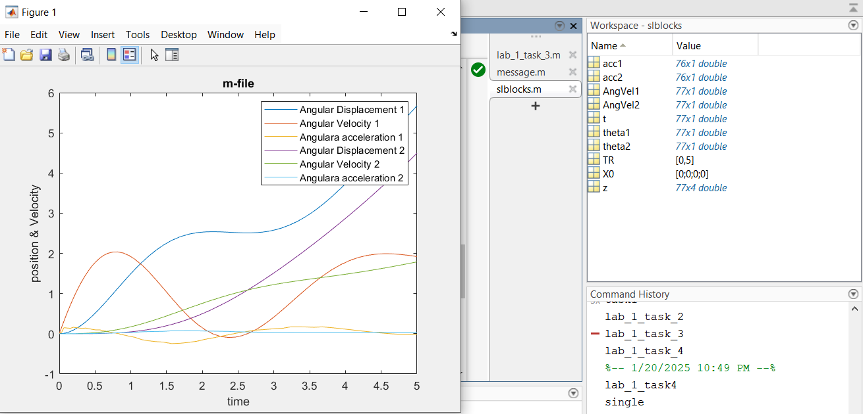

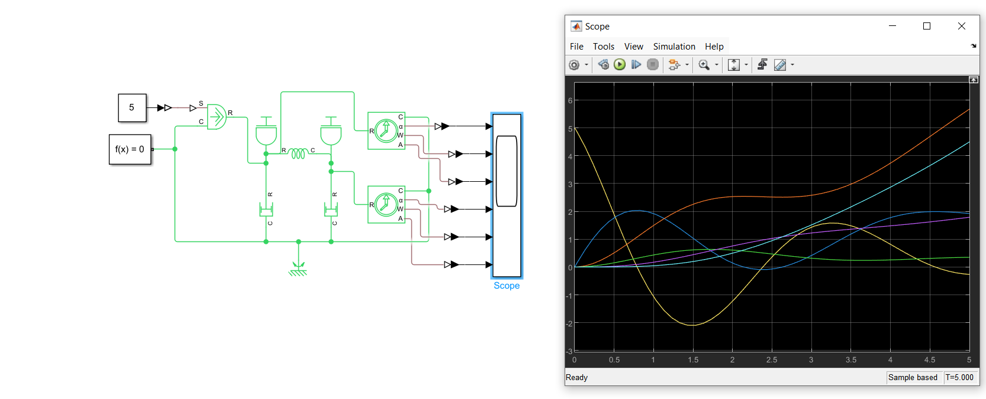

simulink

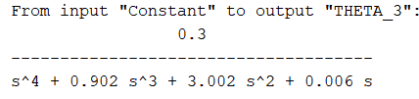

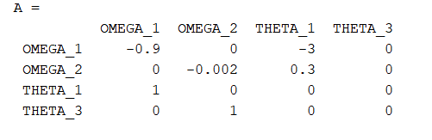

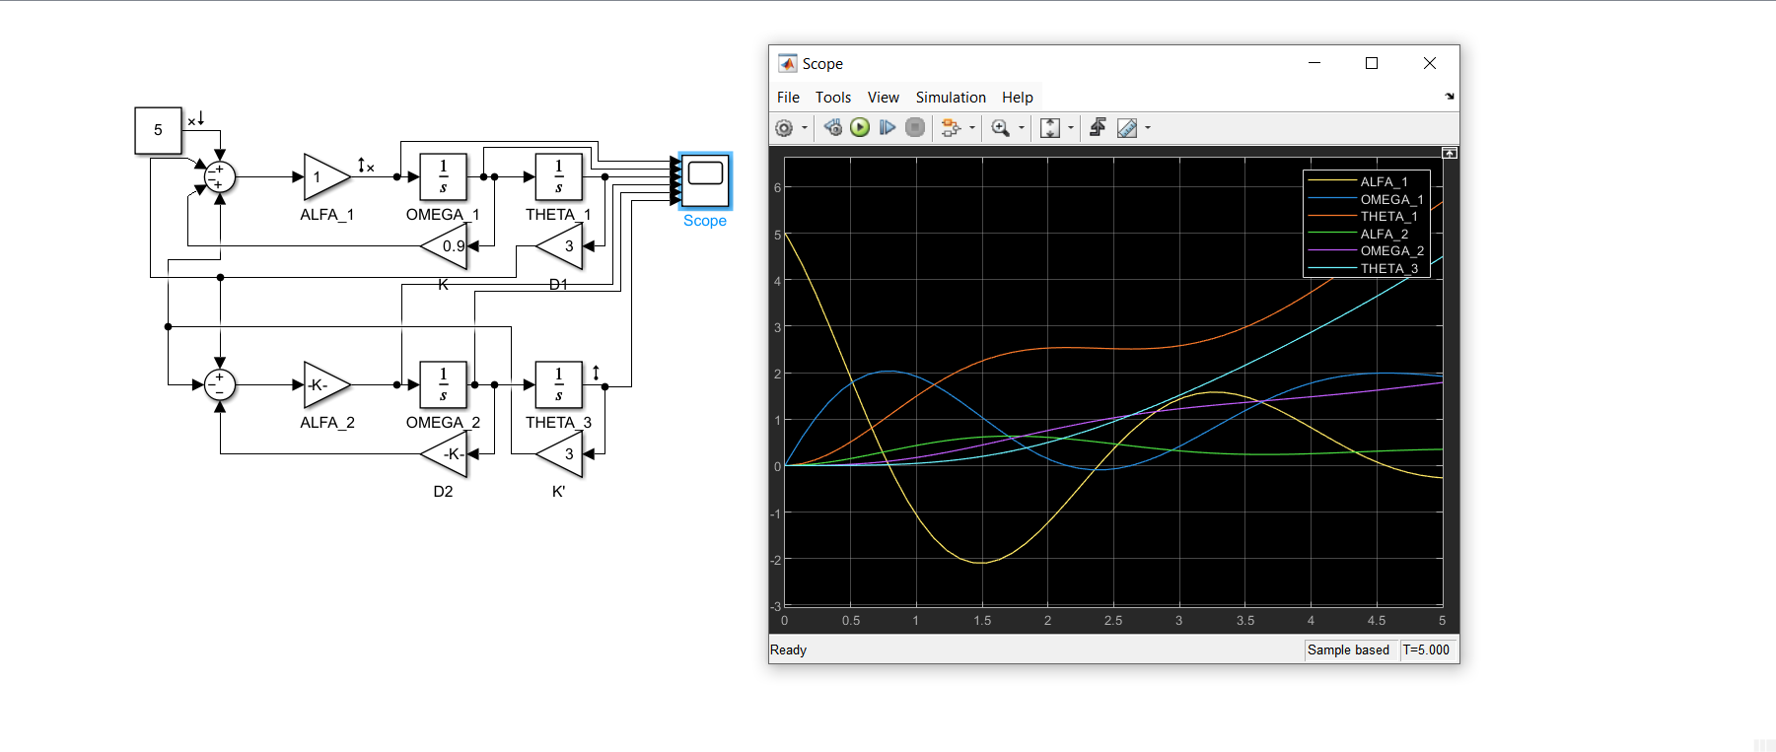

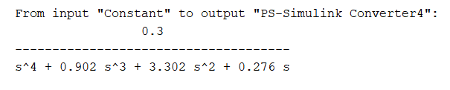

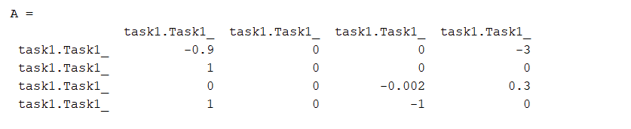

clc

clear

TR = [0 5]; % time RANGE

X0 = [0;0;0;0];%initial conditions

[t,z] = ode45(@func1, TR, X0);%calling thr ide solver to solve by function

%storing given array as vectors

theta1 = z(:, 1);

AngVel1 = z(:, 2);

theta2 = z(:, 3);

AngVel2 = z(:, 4);

%plotting the angular displacements and velocities

acc1 = diff(AngVel1);

acc2= diff(AngVel2);

plot(t,theta1,t,AngVel1,t,[0;acc1],t,theta2,t,AngVel2,t,[0;acc2]);

xlabel('time')

legend('Angular Displacement 1','Angular Velocity 1','Angulara acceleration 1','Angular Displacement 2','Angular Velocity 2','Angulara acceleration 2')

ylabel('position & Velocity')

title("m-file")

%function containing the differentialequationsa

function dx = func1(~, x)

% Values of Coefficients

% J1=1; J2=10; D1=0.9; D2=0.02; k=3

T=5;

%

% State Equations

dx(1) = x(2);

dx(3) = x(4);

dx(2) = (T-2\*x(2)-x(1)+x(3)+x(4));

dx(4) = (x(2)-x(3)-2\*x(4)+x(1));

dx = dx';

end

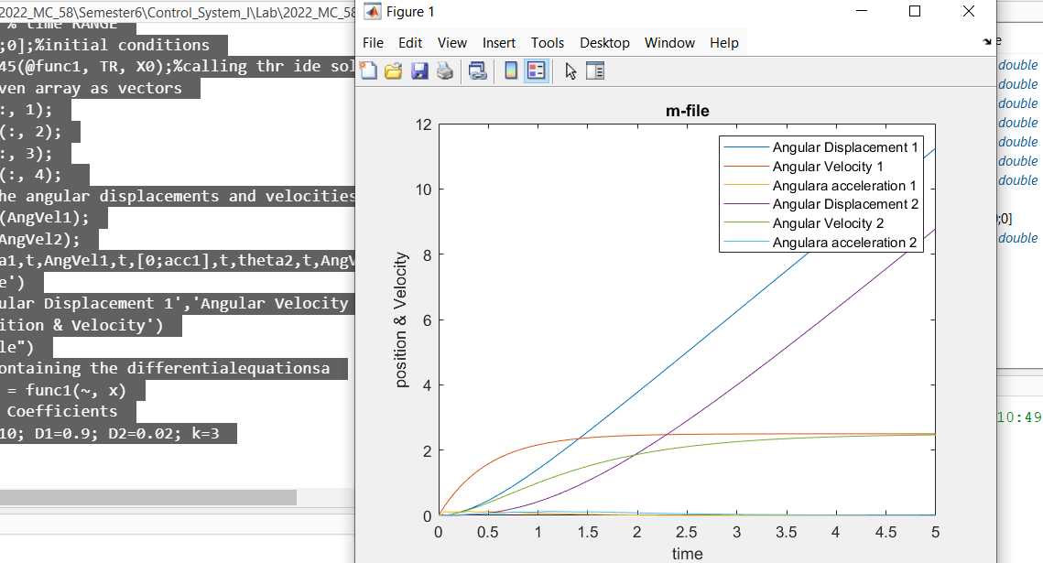

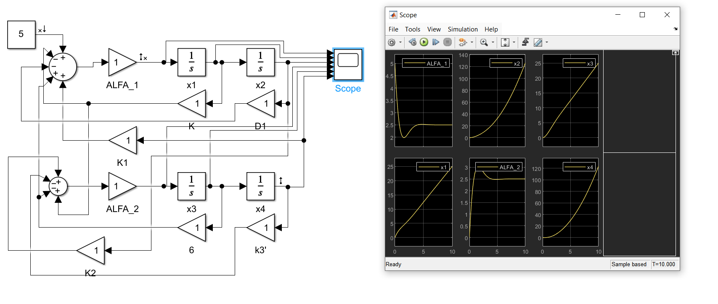

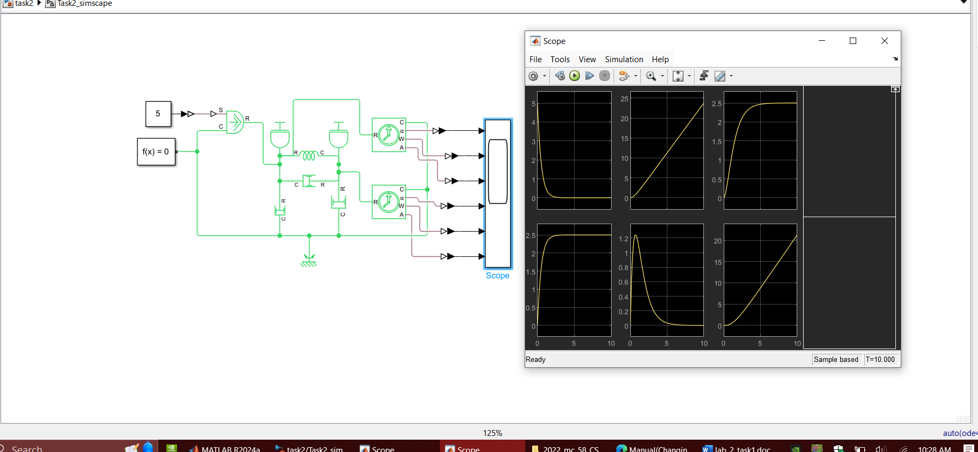

clc;

TR=0:0.01:10;

x0=[0;0;0;0];

[t,x]=ode45(@Task3Fun,TR,x0);

th1=x(:,1);

om1=x(:,2);

alpha1=gradient(om1)./gradient(t);

th2=x(:,3);

om2=x(:,4);

alpha2=gradient(om2)./gradient(t);

subplot(2,3,1);

plot(t,th1);xlabel('time');ylabel('theta 1');

subplot(2,3,2);

plot(t,om1);xlabel('time');ylabel('omega 1');

subplot(2,3,3);

plot(t,alpha1);xlabel('time');ylabel('alpha 1')

subplot(2,3,4);

plot(t,th2);xlabel('time');ylabel('theta 2');

subplot(2,3,5);

plot(t,om2);xlabel('time');ylabel('omega 2');

subplot(2,3,6);

plot(t,alpha2);xlabel('time');ylabel('alpha 2')

%%%%%%%%%%%%%%%%%%%%

function dy=Task3Fun(t,y)

T=1;

dy(1)=y(2);

dy(2)=1/5\*(y(4) + 9\*y(3) - 9\*y(2) - 9\*y(1));

dy(3)=y(4);

dy(4)=1/3\*(T+y(2) + 9\*y(1) - y(4) - 12\*y(3));

dy=dy';

end

